**Converting Python Code to Mathematical Formula: Breaking Down the Code**

**Mean User Rating**

mean_user_ratings = ratings. Mean(axis=1)

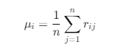

**Ratings Difference**

ratings_diff = (ratings - mean_user_rating [: np. new axis])



**Prediction**

pred = mean_user_rating[:, np.newaxis] + similarity.dot(ratings_diff) / np.array([np.abs(similarity).sum(axis=1)]).T

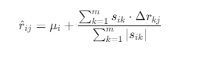

pred = ratings.dot(similarity) / np.array([np.abs(similarity).sum(axis=1)])

